**9-3 Model fitting to data using Bayesian inference**

**PART I: Fitting the catalytic model to seroprevalence data to estimate the force of infection**

We will first analyze the data from the UK (“seroprevalence_uk”):

Ignoring the maternal antibodies, write the formula for the proportion of age “a” who have ever been infected in terms of force of infection “ $λ$”. Fit the catalytic model to seroprevalence data to estimate the force of infection using Bayesian in which Binomial distribution is assumed for the data.

1. Assuming the uniform prior, find the distribution of the force of infection using Metropolis-Hastings algorithm to implement MCMC. Graph the trace plot, distribution and autocorrelation for the force of infection using different initial values and number of iterations.

* Number of samples : 100, 1,000, 10,000, 100,000 and burn-in : first 5%
* Posterior distribution

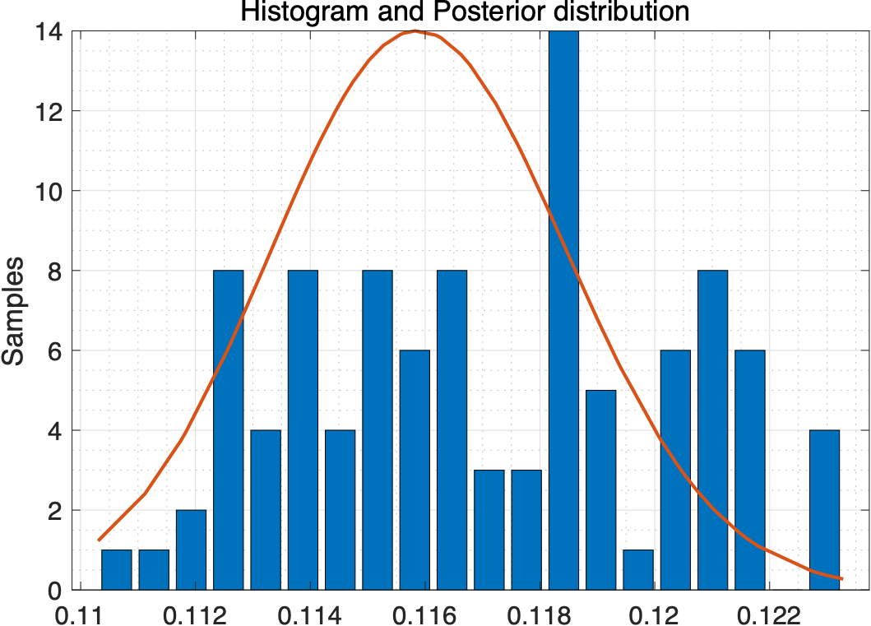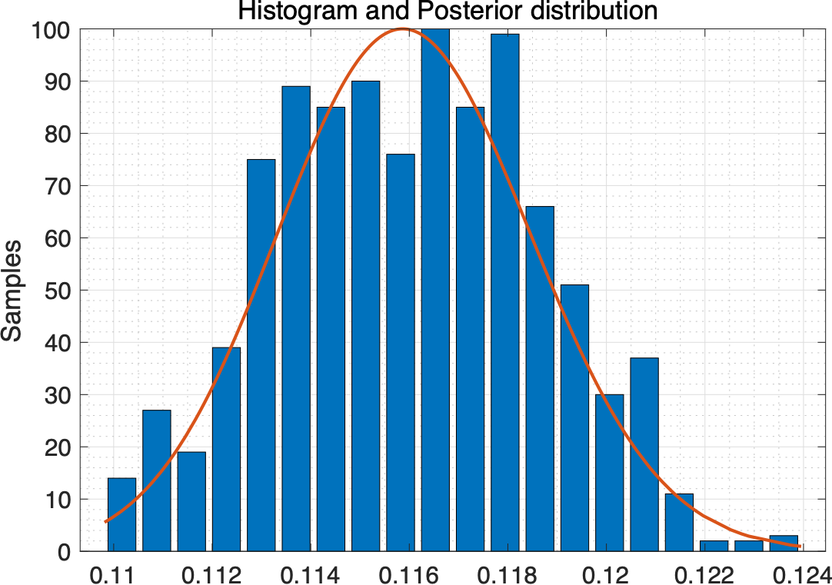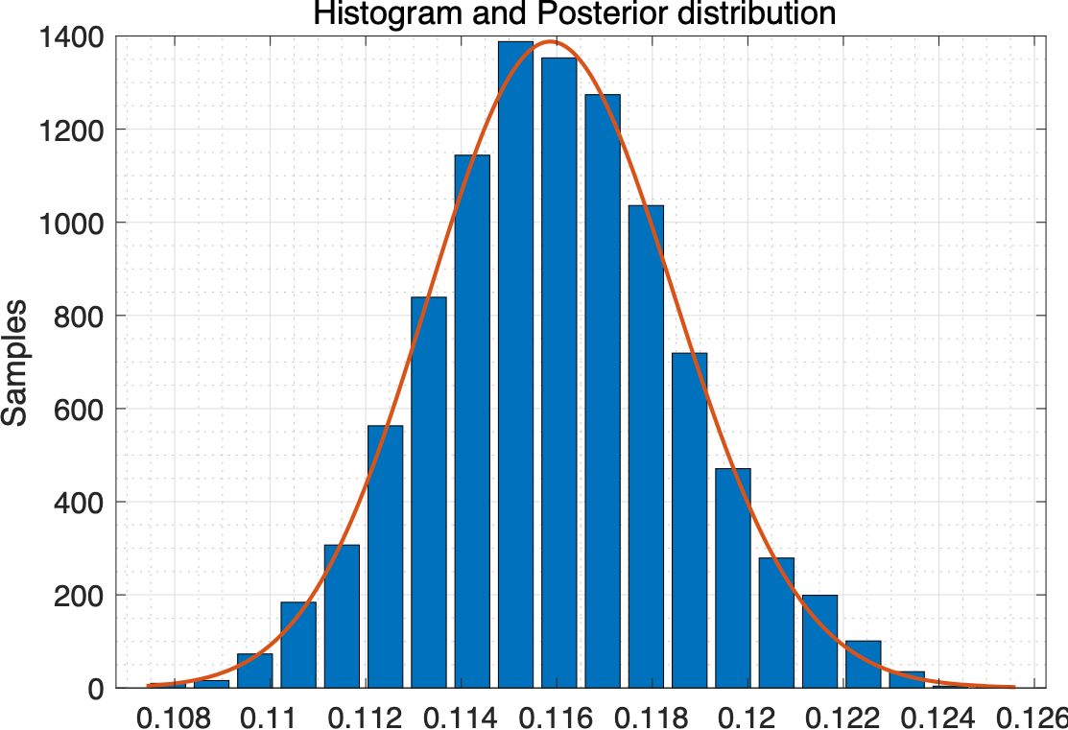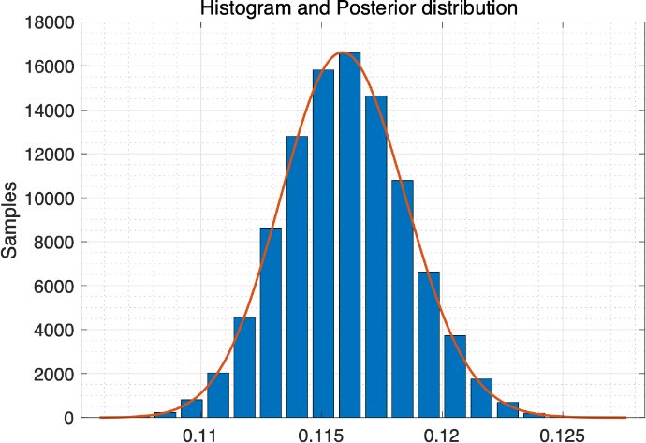

* Trace and Autocorrelation

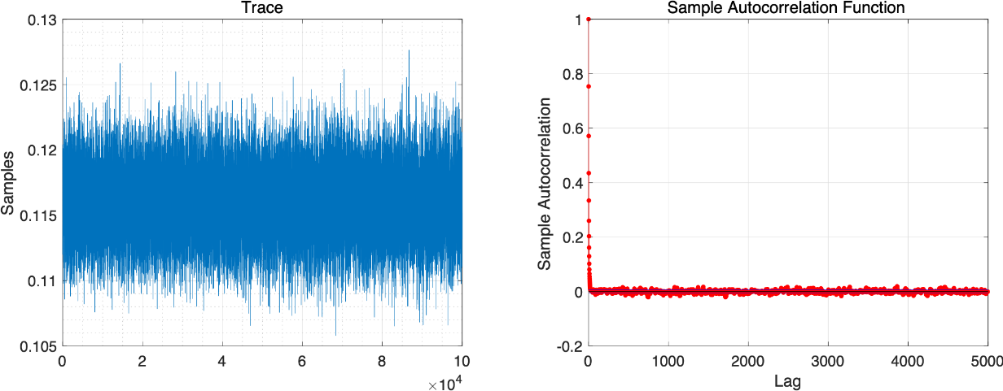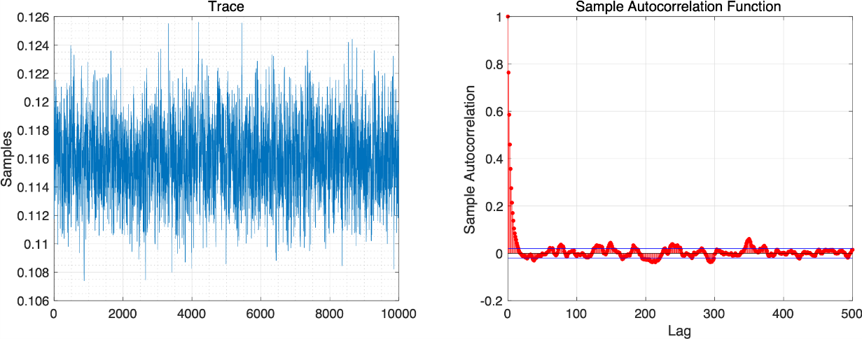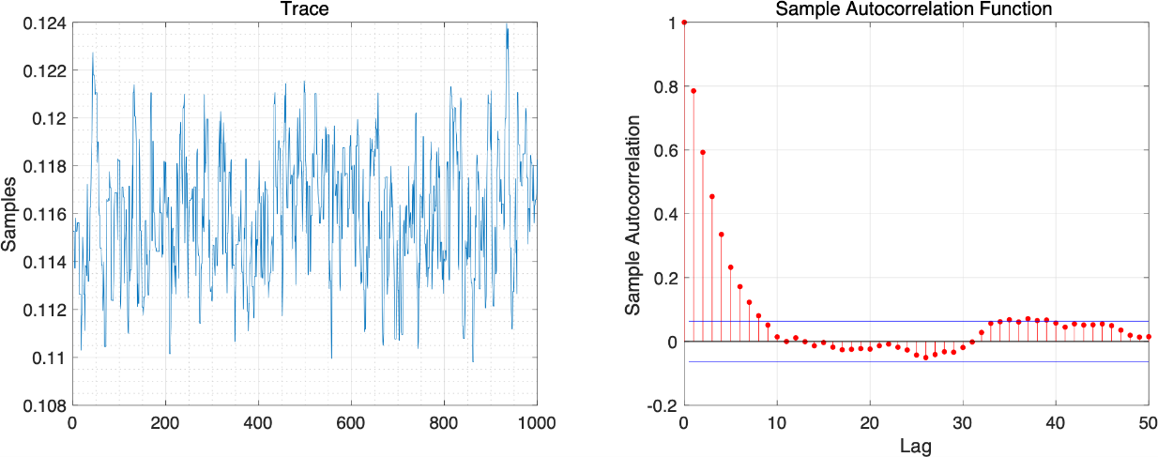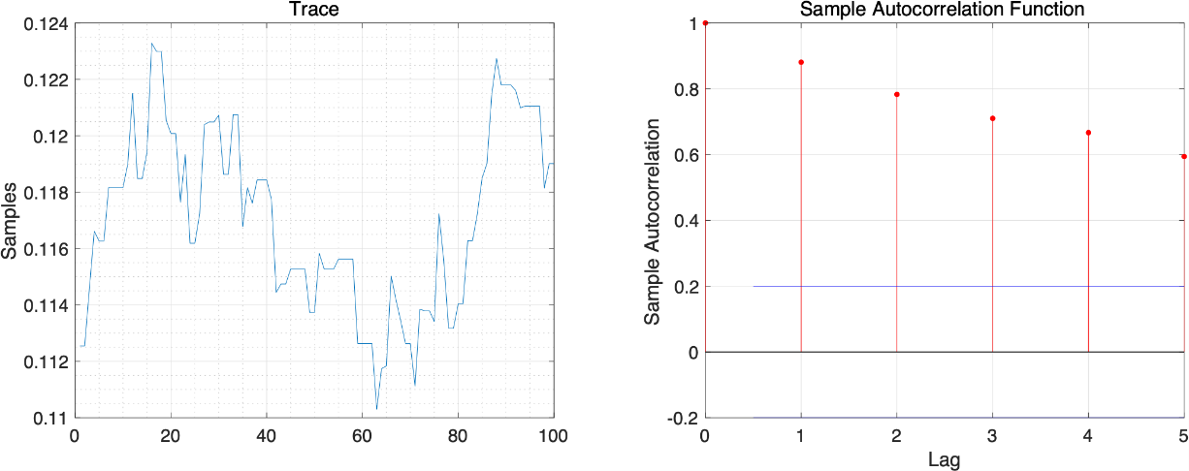

1. Calculate the best-fitting force of infection, the average age at infection, the R0 (assuming that the life expectancy is 60 years) and herd immunity threshold with 95% credible interval.

* Plot for a data and prediction plot using best-fitted value

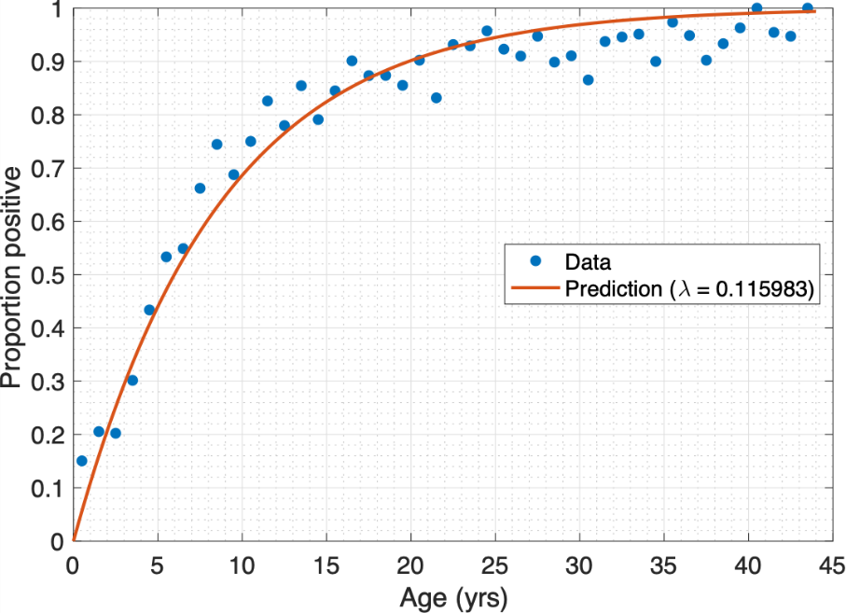

* Force of infection
  + Value : 0.115983
  + Confidence interval : [0.110966 0.121159]
* Average age of infection
  + Value : 8.621953
  + Confidence interval : [8.253598 9.011800]
* R0
  + Value : 6.958981
  + Confidence interval : [6.657937 7.269557]
* Herd immunity threshold
  + Value : 0.856301
  + Confidence interval : [0.849803 0.862440]

Fit the catalytic model to China data (“seroprevalence _china”) to estimate the force of infection:

1. Graph the trace plot, distribution and autocorrelation for the force of infection.

* Number of samples : 100, 1,000, 10,000, 100,000 and burn-in : first 5%
* Posterior distribution

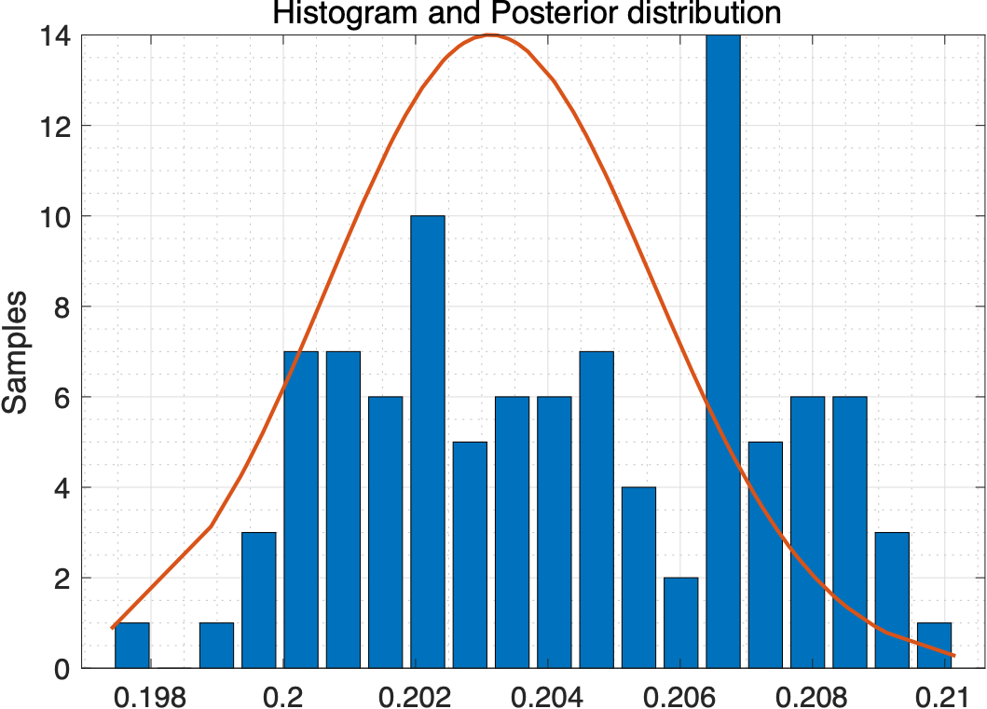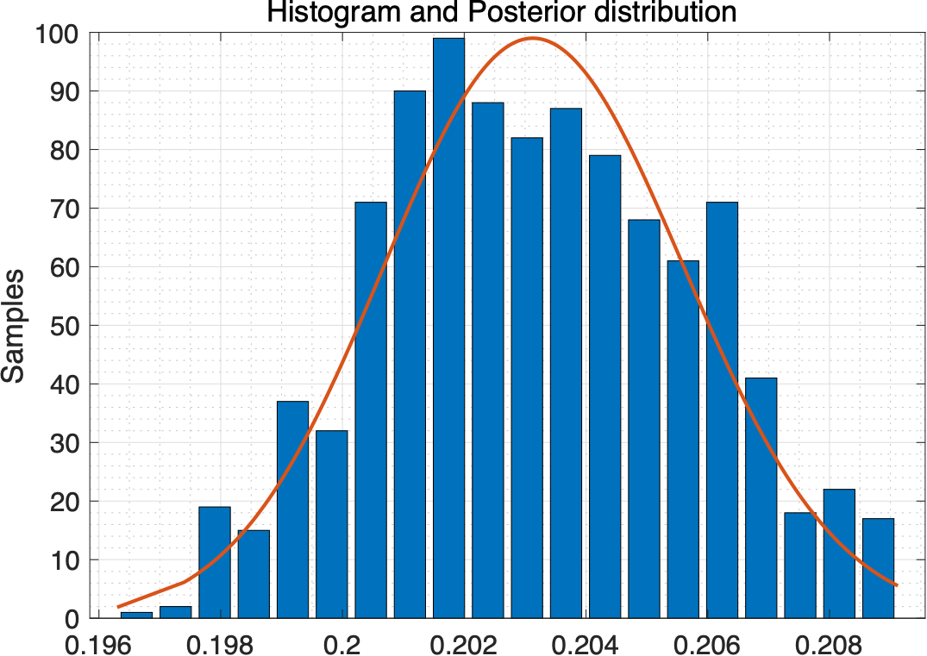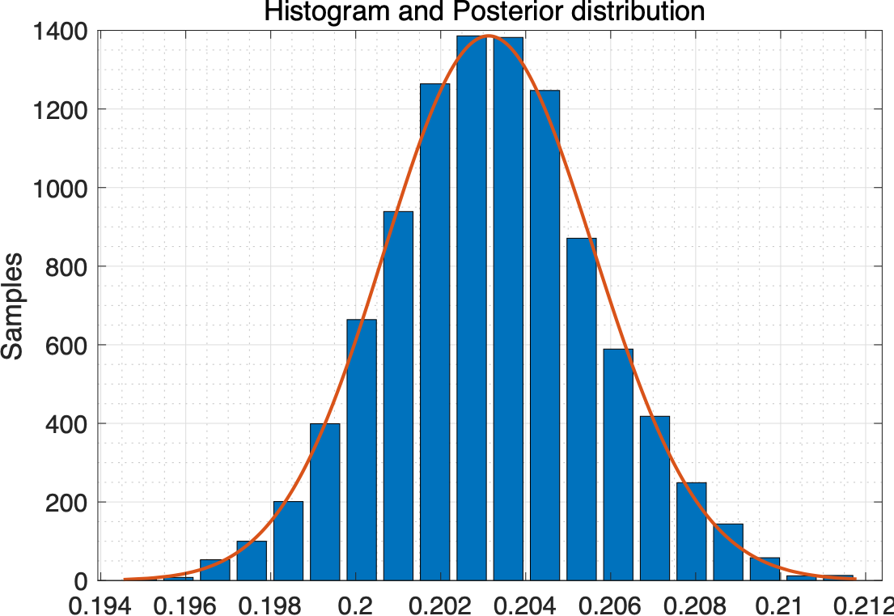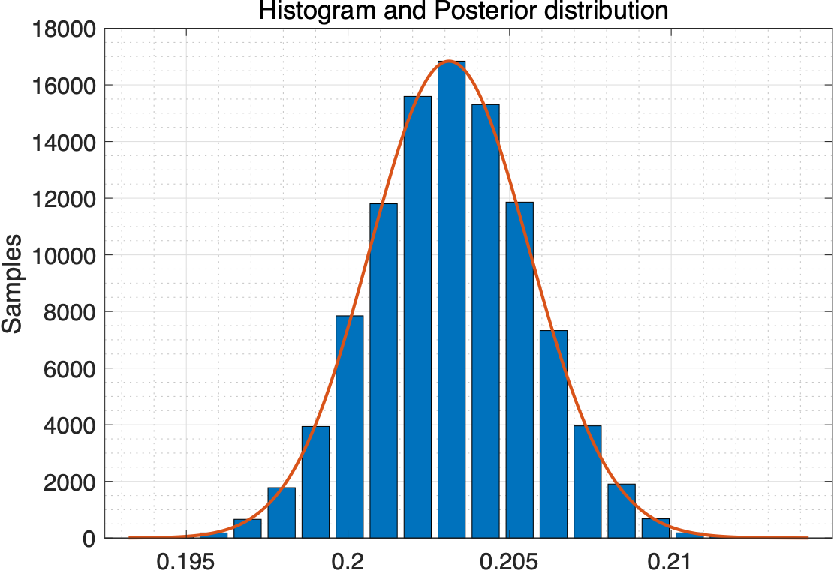

* Trace and Autocorreation

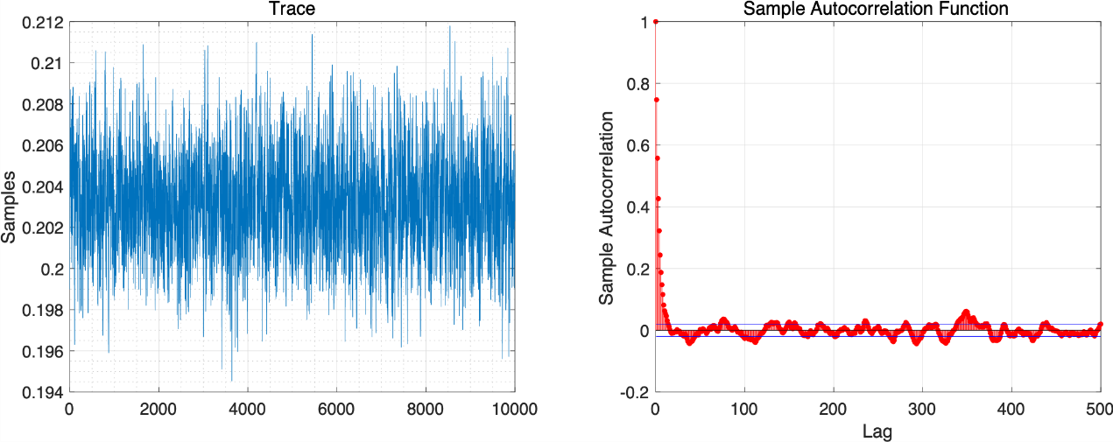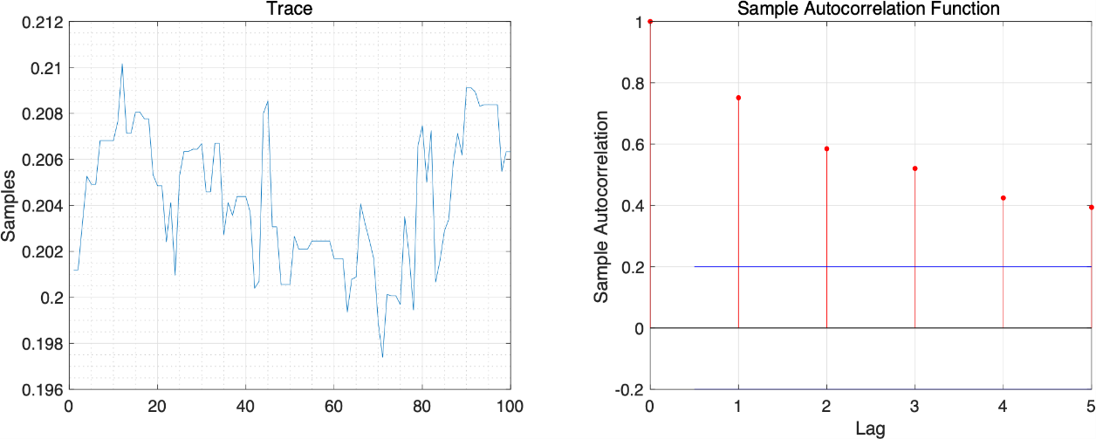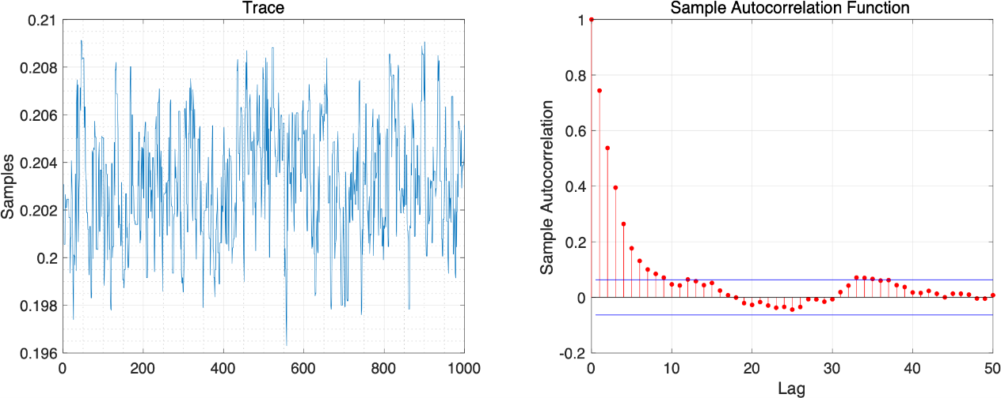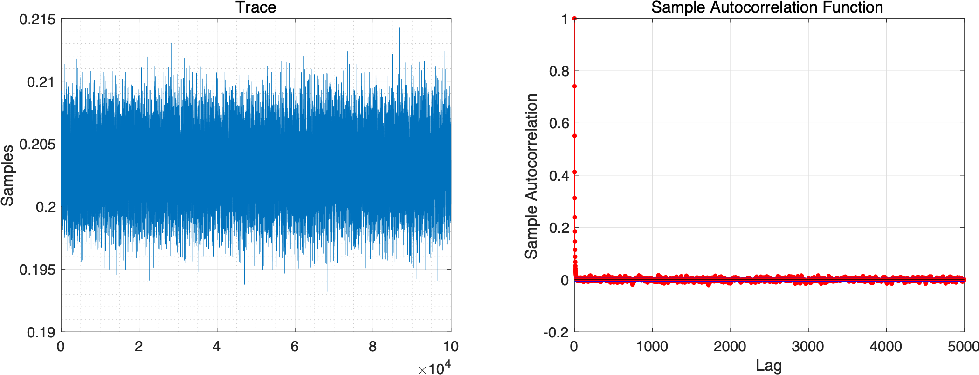

1. Calculate the best-fitting force of infection, the average age at infection, the R0 (assuming that the life expectancy is the same as that in the UK) and herd immunity threshold with 95% credible interval.

* Plot for a data and prediction plot using best-fitted value

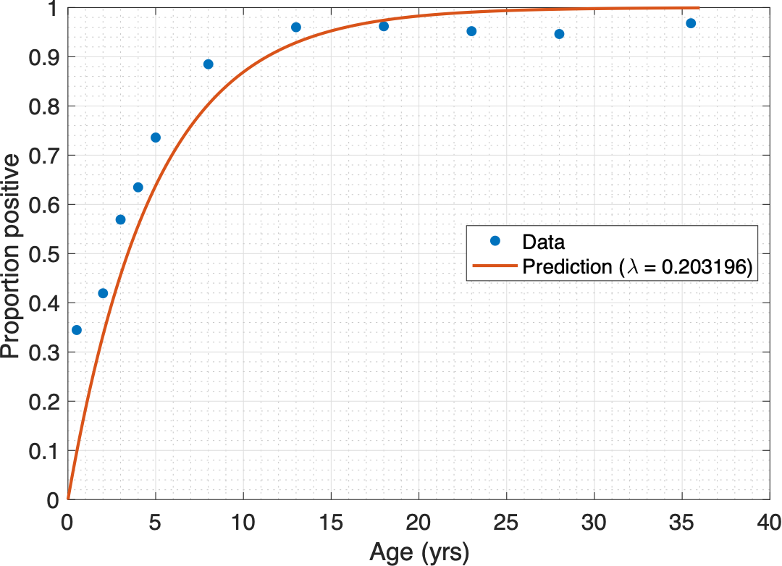

* Force of infection
  + Value : 0.203196
  + Confidence interval : [0.198385 0.208067]
* Average age of infection
  + Value : 4.921352
  + Confidence interval : [4.806145 5.040710]
* R0
  + Value : 12.191772
  + Confidence interval : [11.903086 12.484017]
* Herd immunity threshold
  + Value : 0.917977
  + Confidence interval : [0.915988 0.919898]

**PART Ⅱ: Fitting transmission model to prevalence data to estimate the transmission rate**

Set up the SEIR model of the transmission dynamics of measles in a closed population using differential equations. We assume that individuals mix randomly and parameter and initial values are given as follows:

Population 100000 people

Pre-infectious period 8 days

Infectious period 7 days

Initial values (S,E,I,R)=(99999,0,1,0)

Fit the SEIR model to prevalence data to estimate the transmission rate using Bayesian in which Poisson distribution is assumed for the data (“prevalence_measles”):

1. Graph the trace plot, distribution and autocorrelation for the force of infection.

* Number of samples : 100, 1,000, 10,000, 100,000 and burn-in : first 5%
* Posterior distribution

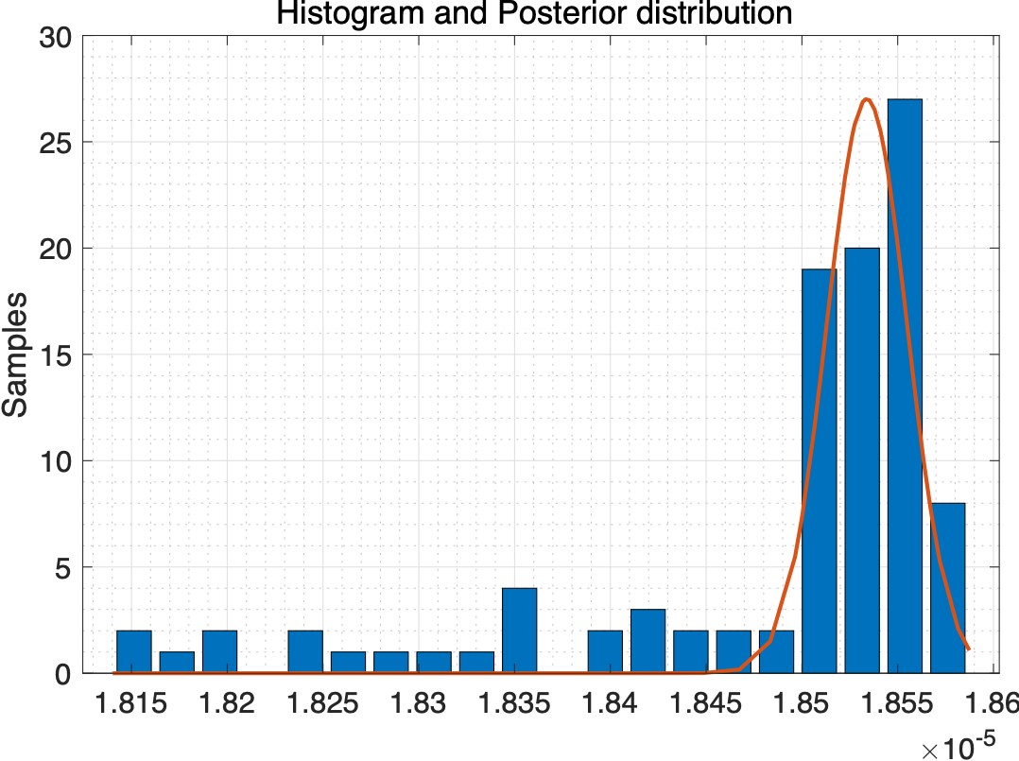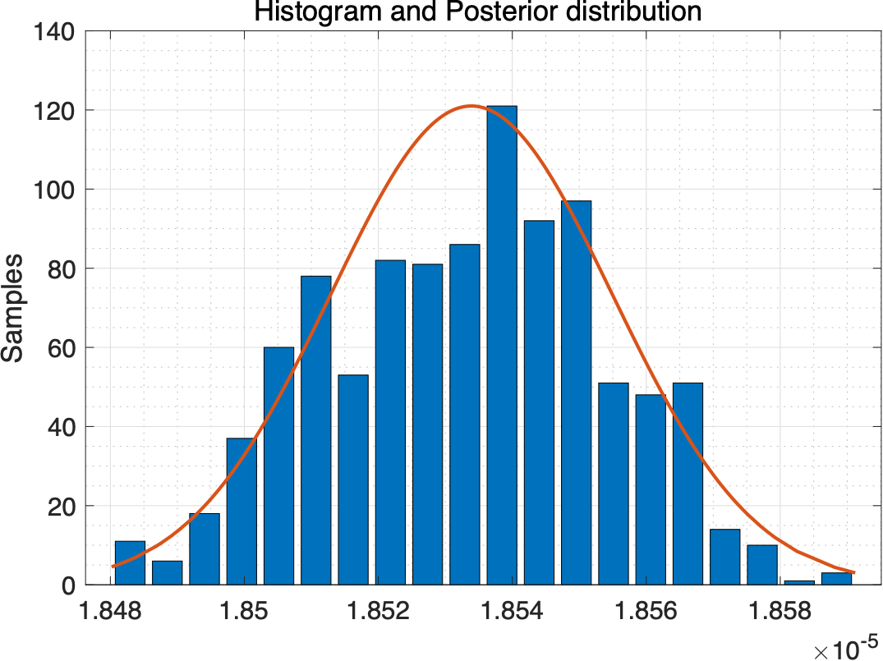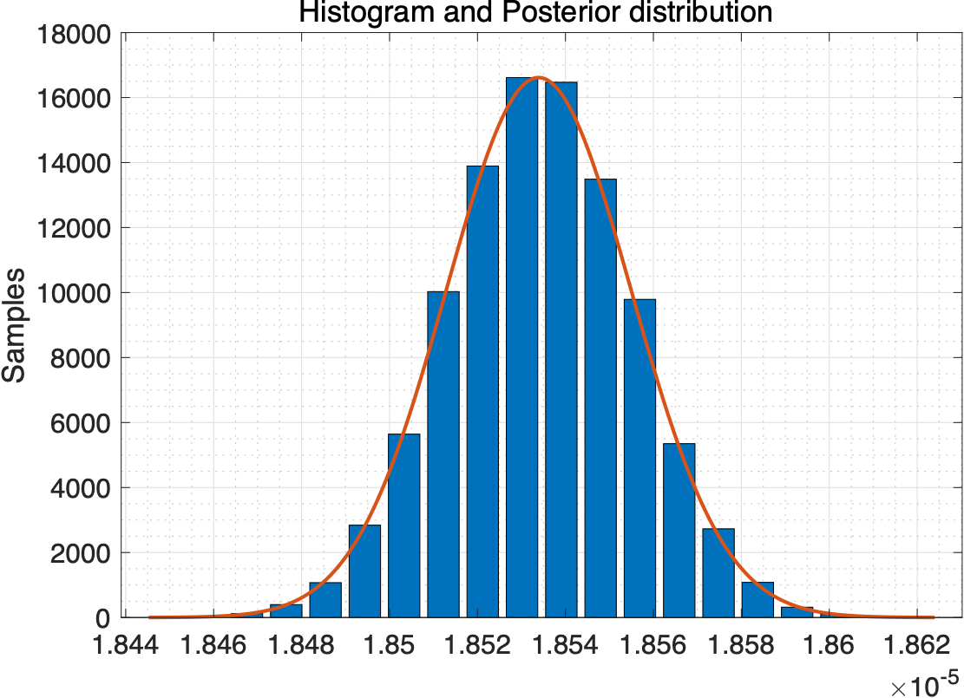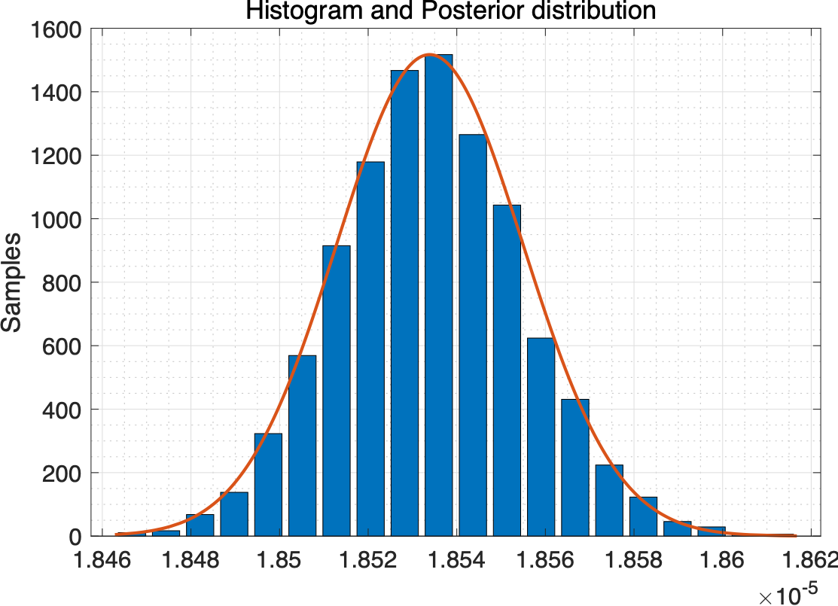

* Trace and Autocorrelation

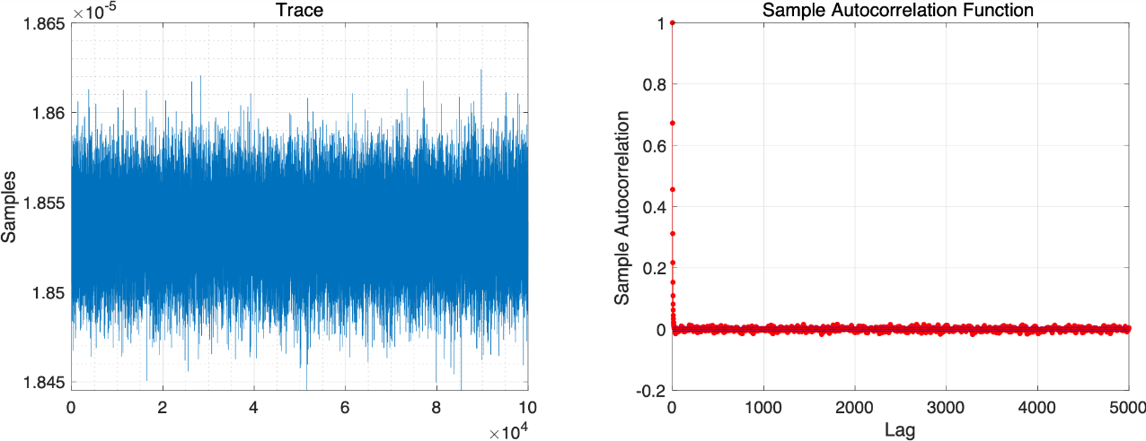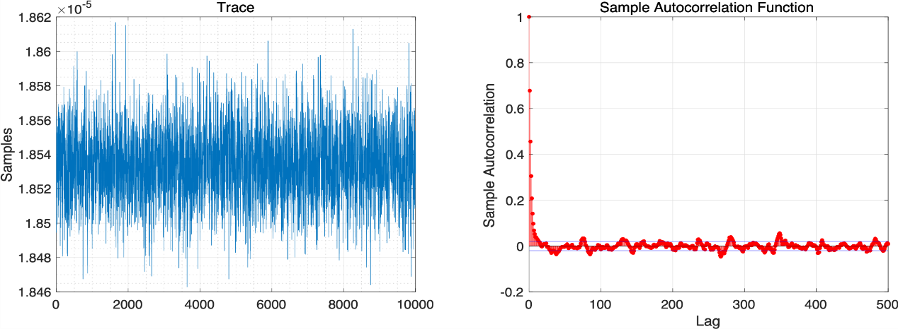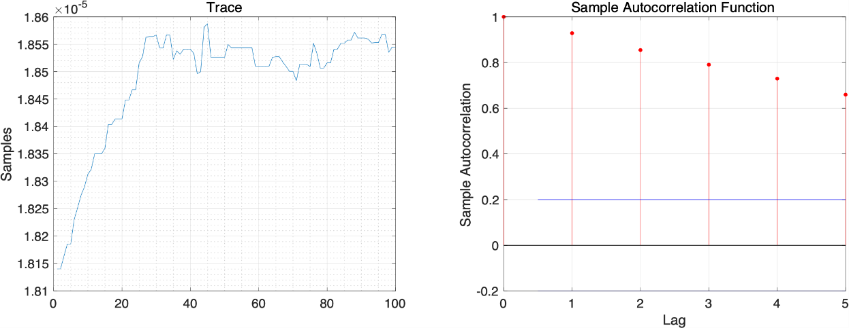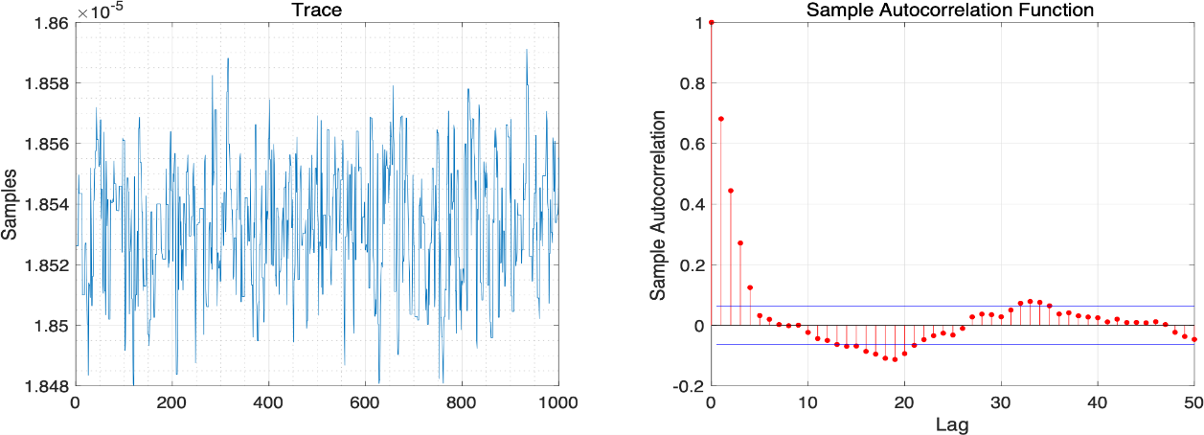

1. Calculate the best-fitting transmission rate, R0 and herd immunity threshold with 95% credible interval.

* Plot for a data and prediction plot using best-fitted value

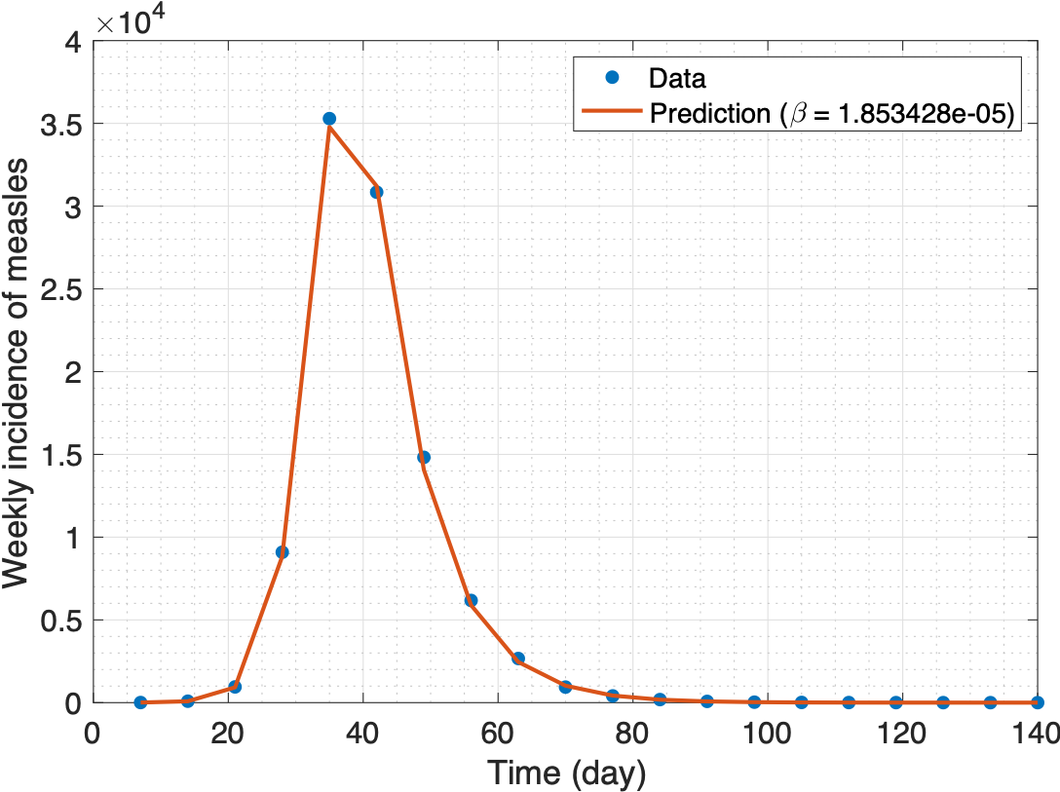

* Force of infection
  + Value : 1.853428e-05
  + Confidence interval : [1.849349e-05 1.857508e-05]
* R0
  + Value : 12.973866
  + Confidence interval : [12.945317 13.002429]
* Herd immunity threshold
  + Value : 0.922922
  + Confidence interval : [0.922752 0.923091]